Inventory Search by a given date

* First I created a Table Using SQL with four columns Materials, Transaction Qty, Closing Qty enter the below query:

CREATE TABLE inventory (

Materials VARCHAR(50),

Transaction_qty INT,

Closing_qty INT,

Date_Time DATETIME

);

* Then Let’s assume the materials in the table as “A”, ”B”, ”C” with the transaction values as both positives and negatives showing addition and removal of stock.
* Then I entered random values of transaction for different materials along with random date and time values using the below query:

INSERT INTO inventory (Materials, Transaction_qty, Closing_qty, Date_Time) VALUES

('A', 50, 50, '2022-01-01 08:00:00'),

('B', 20, 20, '2022-01-02 10:30:00'),

('C', 100, 100, '2022-01-03 14:15:00'),

('A', -30, 20, '2022-01-05 09:45:00'),

('B', 20, 40, '2022-01-06 13:00:00'),

('A', 25, 45, '2022-01-07 16:30:00'),

('C', -30, 70, '2023-01-08 16:00:00'),

('B', 100, 140, '2023-01-09 17:00:00'),

('A', 75, 120, '2023-01-10 18:00:00');

* Table with the following data will look like :

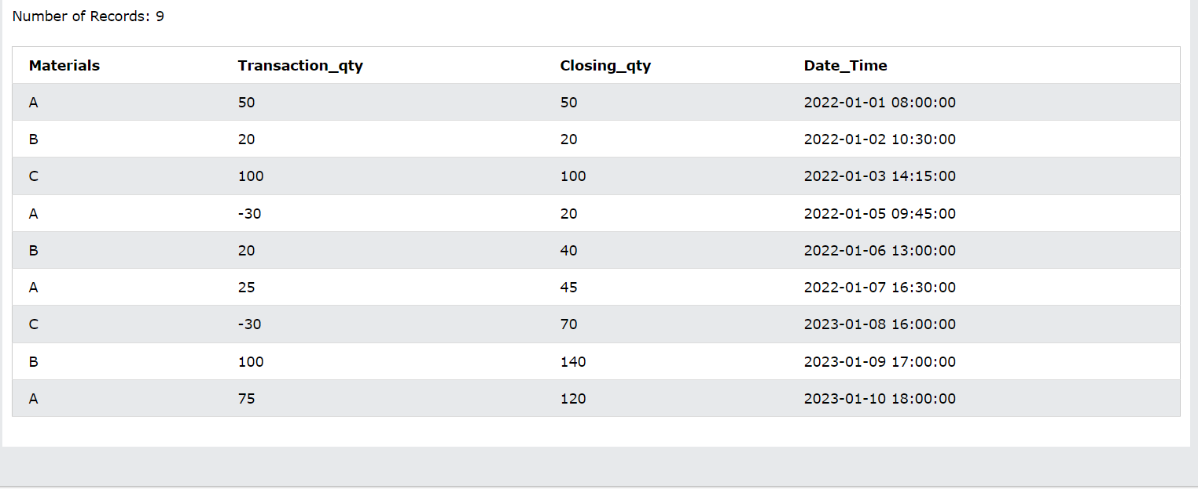

* Now to create a table showing the Materials till a given date I used the query below:

SELECT Materials, Closing_qty

FROM inventory

WHERE Date_Time <= '2022-01-07'

ORDER BY Date_Time DESC

LIMIT 3;

* Result with date 2022-02-05

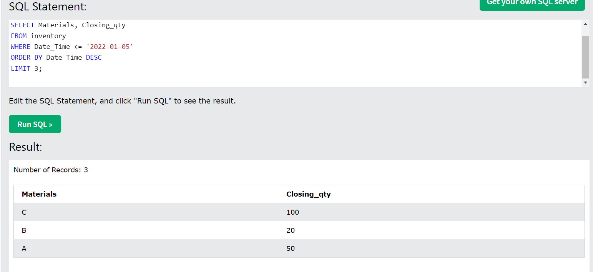

* Result with date 2022-02-07

